NorthPoint Campus Expansion
November 2016

NorthPoint Health & Wellness Center and Hennepin County, in coordination with Thor Development and Estes Funeral Chapel will be expanding the NorthPoint Campus at the intersections of Plymouth and Penn Avenue North. The campus will expand by 74,000 sf. Services will continue during construction.

Features of the Campus expansion
When completed the NorthPoint expansion will:

- Increase off street parking for patients and employees
- Increase community access to health and wellness services and activities
- Increase community space
- Increase employment, training and community education
- Enhance green spaces
- Increase optimal patient flow

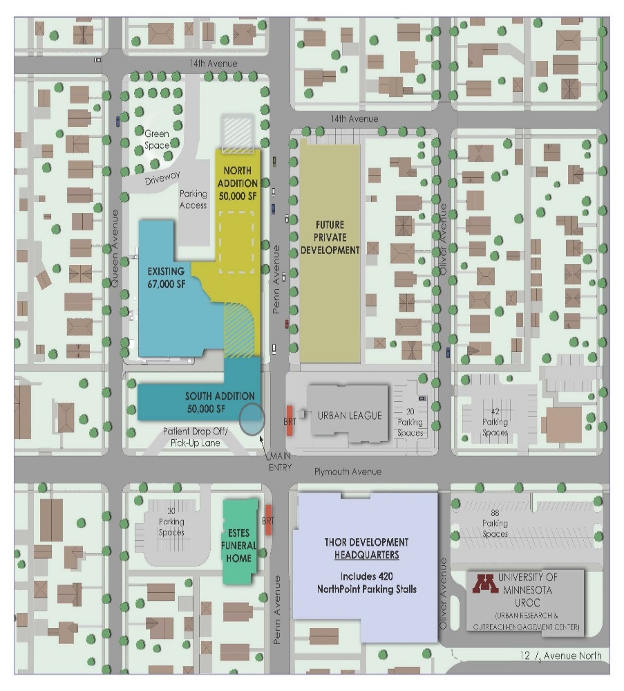

Anticipated building schedule

2017 Completing the design of the campus

2018 Anticipating that construction will begin

Contact
Sherrie Simpson
Director – Planning, Communication, Engagement
sherrie.simpson@hennepin.us
612-543-2579
www.northpointhealth.org

11.09.16

